Quiz 3

Q1) 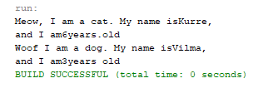

Q2) Because in the class animal we already set the public for int for age and String for name. So that, in class of cat and dog we just use this and super method to call out the figure in the class then send to main class.

Q3) object kurre and vilma contain instance of Cat and Dog.

Q4) Animal.java, Cat.java,Dog.java and Lab1stage2.java there are a class consists of properties and method.

Q5) A class acts as a blueprint of an object or instance. A class defines the properties and methods of an object or instance while the instance is the object of a class created to be used in a program.

Q6) 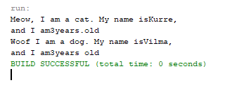

Two output of age become 3 only, this is why because adding the static is a variable that has been allocated ”statically”, meaning that its lifetime (or “extent”) is the entire run if the program.

Q7) kurre and vilma are variable in the main method class in Lab1stage2. Then it belongs main method inside Lab1stage2.

Q8) age is property of Animal class and it store in animal class.

Q9) this keyword will make sure the current class of the two will be used instead